GRAB YOUR GO BAG AND PETS AND THEN LEAVE!

Let's Get Ready

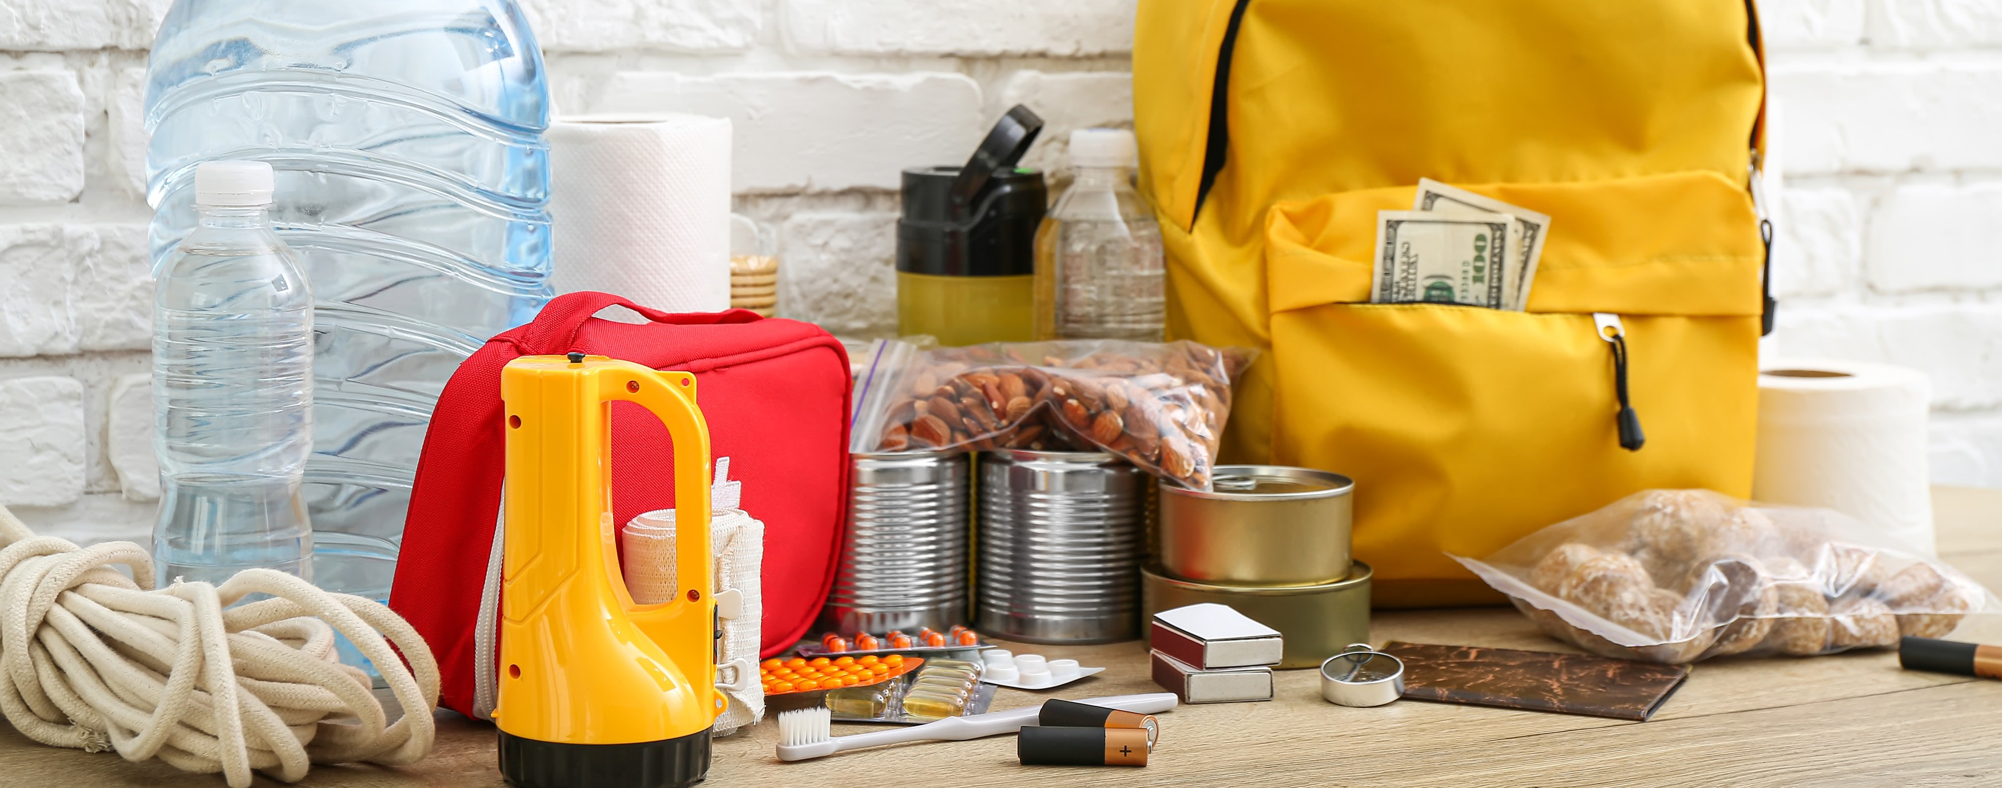

PREPARE YOUR GO BAG!

A fire or some other emergency has occurred. You have 15 minutes to leave your house. Make a list of what you would take. Then compare your list with a neighbor sitting by you.

Add items after discussing with someone sitting near you.

Add items after the presentation on the back side of this paper.